LAB 9 – Bridge Pattern

a. The deciding factors that determine which of these two patterns (Bridge, Strategy) should be applied in a particular situation.

Bridge pattern has two parts: “abstraction” and “implementation”. It helps decouple abstraction and implementation. In the other side, Strategy pattern define a family of algorithms, let them vary independently from clients that use it. We can consider “implementation” of Bridge pattern as strategy pattern. Because both of them can vary independently from client(“abstraction”). So when you just want to vary only strategy for one client. You can apply strategy pattern. If you also want to vary on client side, you can apply bridge pattern.

b. Example to illustrate

We need to build an EbookReader in general, it can read various format, depending on the input, ex. Epub, Pdf, Mobi...

Depending on the input format, we will use the appropriate EbookReaderAPI to handle.

So the Bridge pattern should be like following.

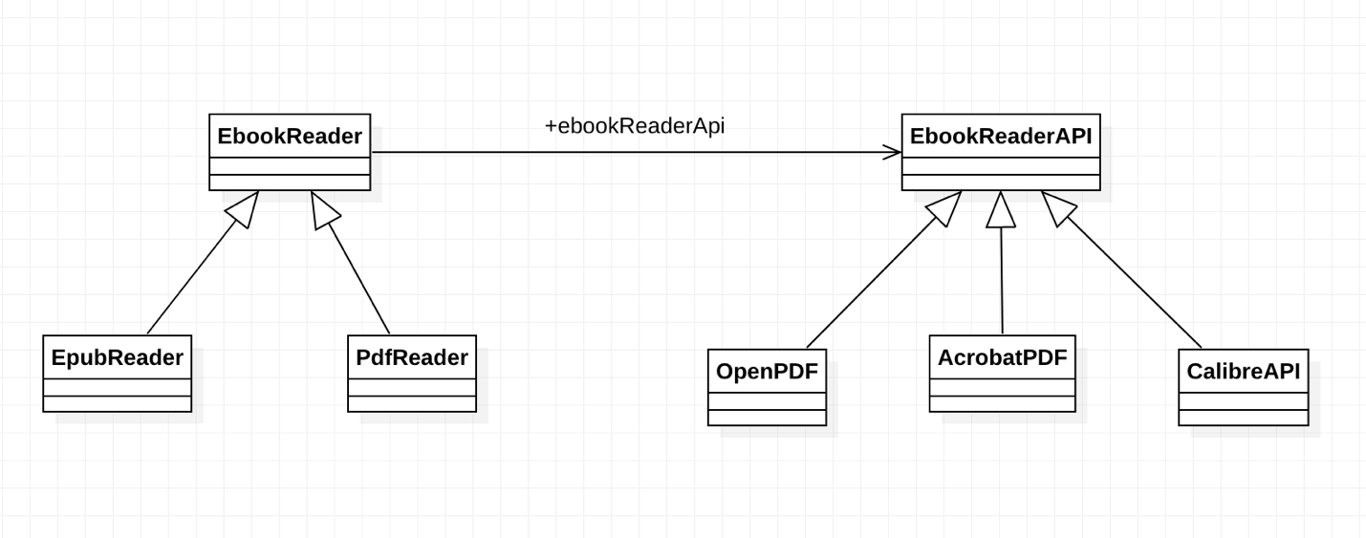

However, if we only need to build EbookReader for PDF format, then we don't need to abstract the EbookReader.

The diagram will be following:

